Data Science Academy Assignment

1. Show all the makes of cars available in the dataset and how many cars there are for each make.

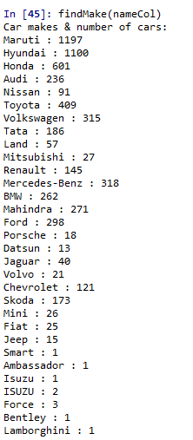

1. Which city has the most used cars?

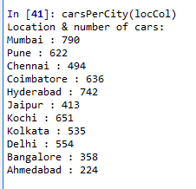

1. What is the distribution of the model year of the used cars?

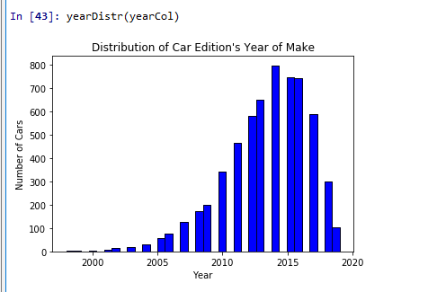

1. How many cars have a total distance usage of under 100,000 kilometers?



1. At what upper and lower limits can the total distance travelled be categorised as "low" or "high"? Include arguments for your answer.

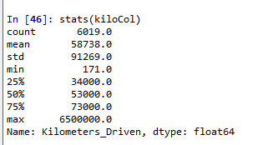

1. Are there any outliers in the Kilometers_Driven column? Include arguments for your answer.

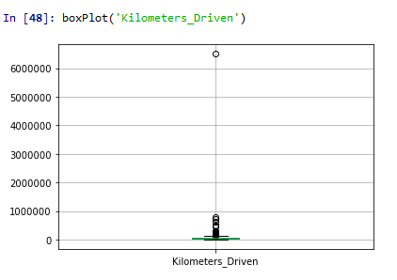

Maximised version – without furthest outlier:

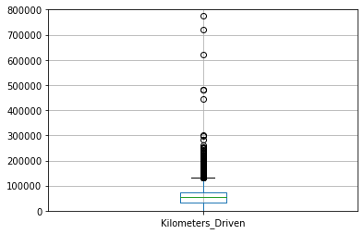

1. Does the year of manufacture correspond to the total distance usage?

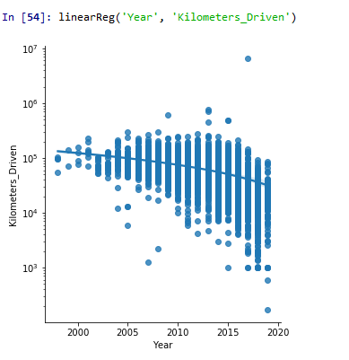

1. How many cars have had three owners already?



1. Which type of fuel is the most efficient in terms of fuel consumption?

